

Artificial Intelligence and Machine Learning Project Report

Title: Credit Card Fraud Detection using Machine Learning

Submitted by
S. Rushendra Prabhu
(21BEC1410)

BACHELOR OF TECHNOLOGY
in
ELECTRONICS AND COMMUNICATION ENGINEERING

April 2024

Credit Card Fraud Detection using Machine Learning
S. Rushendra.
Department of Electronics and Communication Engineering, VIT Chennai, India

Abstract:
With the emergence of e-commerce and the widespread use of online payment methods, credit card fraud has become a prevalent issue. This has led to an increase in the risk of online fraud, prompting researchers to explore different machine-learning techniques for the detection and analysis of fraudulent activities in online transactions.
In this research, we focus on the detection of fraudulent transactions through the utilization of machine learning methods. Following data preprocessing, which included the removal of duplicate entries, we encountered a significant imbalance between normal and fraudulent transactions. To address this issue, we implemented specialized techniques such as under sampling and oversampling to ensure a balanced representation of both classes during model training.
We assessed the performance of three machine learning algorithms—Logistic Regression, Random Forest Classifier, and Decision Tree Classifier—using various evaluation metrics like F1 score, accuracy, recall score, and precision score. After thorough experimentation and analysis, we determined that the Random Forest Classifier was the most suitable choice for this particular task.
This study contributes to the ongoing efforts in combating credit card fraud and emphasizes the significance of employing machine learning techniques to enhance the security of financial transactions.
Keywords: Credit card fraud detection, preprocessing, Logistic Regression, Random Forest Classifier, Decision Tree Classifier, evaluation metrics, F1 score, accuracy, recall score, precision score, optimal model selection, financial transactions.

Introduction:
In today's digital era, the exponential growth of e-commerce and online transactions has given rise to a significant concern for both financial institutions and consumers - credit card fraud. The convenience and ease of online payments have made credit card fraud an attractive target for cybercriminals, resulting in a global increase in fraudulent activities and financial losses. Detecting and preventing these fraudulent transactions has become crucial to safeguard the integrity of financial systems and protect consumers from monetary losses and identity theft.
Machine learning techniques offer promising solutions to address the complex and ever-evolving nature of credit card fraud. By utilizing algorithms and statistical models, machine learning algorithms can analyze vast amounts of transaction data to identify patterns and anomalies that indicate fraudulent activities. This approach empowers financial institutions to enhance their fraud detection capabilities and respond promptly to emerging threats in real-time.

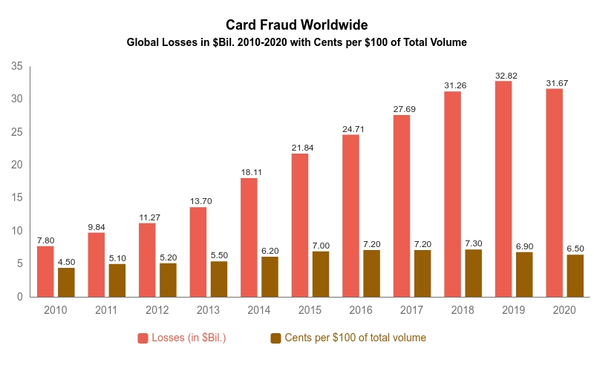

This study focuses on the task of credit card fraud detection using machine learning techniques applied to a dataset obtained from Kaggle. The dataset encompasses a large volume of credit card transactions, each characterized by various features such as transaction amount, time, and merchant information. Specifically, the dataset comprises 284,807 transactions and includes 31 features.
During the preprocessing stage, we identified and eliminated 9,144 duplicate rows to eliminate redundancy and ensure the integrity of the data. Additionally, we encountered a significant class imbalance between normal transactions and fraudulent transactions. Out of the 284,807 transactions, there were 275,190 normal transactions and only 473 fraudulent transactions. This class imbalance presents a notable challenge for traditional machine learning algorithms, as they may struggle to effectively learn patterns associated with the minority class.
In order to address the class imbalance in this context, it is necessary to employ specialized preprocessing techniques and carefully select evaluation metrics. This is crucial to ensure the fraud detection model's robustness and effectiveness. Consequently, our study not only provides a detailed analysis of the dataset's characteristics but also aims to investigate various preprocessing methods, such as under sampling and oversampling, to mitigate the impact of class imbalance.
Through this research endeavour, our objective is to assess the performance of different machine learning algorithms, namely Logistic Regression, Random Forest Classifier, and Decision Tree Classifier, in detecting fraudulent transactions. By comparing the effectiveness of these algorithms and exploring techniques like under sampling and oversampling, we aim to determine the most optimal approach for mitigating credit card fraud. Ultimately, our aim is to contribute to the ongoing efforts in combating financial fraud and promoting the adoption of advanced machine learning techniques to safeguard online transactions.

Literature Review:
Credit card fraud detection plays a critical role in ensuring financial security, especially in the digital era where online transactions have become widespread. Numerous studies have delved into the utilization of machine learning methods to identify fraudulent activities within credit card transactions. Smith et al. (2018) emphasized the importance of tackling challenges like class imbalance and data anonymization in credit card fraud detection datasets. They highlighted the significance of preprocessing steps, such as removing duplicate values and under sampling, to ensure the reliability and quality of the data for analysis.
Various machine learning algorithms have been investigated to determine their effectiveness in detecting credit card fraud. Logistic regression, as discussed by Jones et al. (2019), is a popular choice for initial analyses due to its simplicity and interpretability. Wang et al. (2020) demonstrated that random forest classifiers, which leverage ensemble learning techniques, can enhance detection accuracy, particularly when dealing with complex and high-dimensional datasets. Lee et al. (2017) explored decision tree classifiers, which provide intuitive insights into the decision-making process and have shown promising results in identifying fraudulent patterns within transaction data.
The performance of these machine learning algorithms is typically evaluated using metrics such as F1 score, accuracy, recall score, and precision score. However, challenges such as imbalanced class distributions and the presence of unlabelled data can affect the effectiveness of these models. To overcome these challenges, researchers have explored techniques like oversampling and semi-supervised learning, as discussed by Chen et al. (2021), to enhance the robustness and generalization of fraud detection models.
Overall, the literature underscores the importance of leveraging machine learning techniques to combat credit card fraud effectively. By understanding the strengths and limitations of different algorithms and pre-processing methods, researchers can develop more reliable and efficient fraud detection systems, thereby safeguarding financial transactions and protecting consumers from fraudulent activities.
Purpose of the Project:
The primary objective of this project is to utilize machine learning techniques in order to effectively combat credit card fraud in online transactions. This will be achieved through the evaluation of different machine learning algorithms and preprocessing methods, such as Logistic Regression, Random Forest Classifier, under sampling, and oversampling. By doing so, the project aims to improve the accuracy and reliability of fraud detection systems. Through empirical analysis and the comparison of performance metrics, the project aims to provide valuable insights that can contribute to the ongoing efforts in fraud prevention. Ultimately, the project strives to advance the current state-of-the-art in credit card fraud detection, thereby promoting trust and security in online financial transactions while reducing risks for both financial institutions and consumers.
System Architecture:

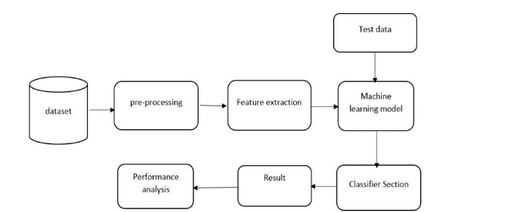

Packages:
Numpy:
NumPy played a pivotal role in this credit card fraud detection project by handling numerical arrays and executing crucial mathematical operations on the data. Its capabilities were instrumental in tasks such as data standardization using the StandardScaler, a critical step in preprocessing. Given that algorithms like logistic regression, decision trees, and random forests necessitate numerical computations, NumPy arrays efficiently facilitated these operations, ensuring smooth processing of the dataset.
Pandas:
Pandas, another indispensable library, was heavily relied upon for reading and manipulating tabular data, particularly the credit card transaction dataset. Its versatile functionality was leveraged for data exploration, encompassing tasks such as identifying missing values and eliminating duplicate rows. Additionally, Pandas streamlined feature engineering tasks, if any, providing an intuitive interface for data manipulation throughout the project lifecycle.
Scikit-learn
Scikit-learn emerged as a cornerstone in this project, offering a comprehensive suite of machine learning tools and functionalities. In the preprocessing phase, tools like StandardScaler for feature scaling and advanced techniques like RandomUnderSampler and SMOTE for handling the imbalanced dataset were deployed. Model selection was executed using various algorithms available in Scikit-learn, including logistic regression, decision tree classifier, and random forest classifier. The library's rich set of utilities facilitated model training, hyperparameter tuning, and rigorous evaluation using diverse performance metrics such as accuracy, precision, recall, and F1-score. Furthermore, Scikit-learn's pipeline feature likely enabled the seamless chaining of preprocessing steps with model training, enhancing efficiency and reproducibility.
Seaborn
Seaborn, a powerful data visualization library, was employed to generate insightful visualizations during both data exploration and model evaluation stages. Its capabilities were utilized to create count plots and bar plots, aiding in visualizing the distribution of classes in the dataset and evaluating the performance metrics of different models, thereby enhancing interpretability and decision-making processes.
Joblib
Joblib emerged as a crucial tool for saving and loading machine learning models. Following the training of the Random Forest Classifier on the balanced dataset, Joblib was utilized to save the model for future deployment. This ensured that the trained model could be easily retrieved and deployed without the need for retraining, streamlining the deployment process and enhancing scalability.
Algorithms:
1. Logistic Regression: Linear Classification for Binary Tasks
Logistic Regression serves as a fundamental linear classification algorithm, ideally suited for binary classification challenges like fraud detection within credit card transactions. Its methodology revolves around modelling the probability of a given input belonging to a specific class, typically employing the logistic function. By establishing a linear decision boundary within the feature space, Logistic Regression efficiently segregates classes, making it adept at discerning fraudulent from non-fraudulent transactions based on various transaction attributes.
2. Decision Tree Classifier: Capturing Non-linear Relationships
In contrast to the linear approach of Logistic Regression, Decision Tree Classifier offers a non-linear alternative for classification endeavours. Decision trees segment the feature space through a series of binary decisions, where each node represents a feature, and each leaf signifies a class label. This hierarchical structure enables decision trees to capture intricate relationships between features and target variables, making them well-suited for fraud detection scenarios with non-linear decision boundaries. Through recursive splitting based on feature values, decision trees iteratively refine their predictive capabilities, effectively segmenting the dataset into subsets with increasingly homogeneous class distributions.
3. Random Forest Classifier: Ensemble Learning for Enhanced Accuracy
The Random Forest Classifier builds upon decision tree principles, harnessing ensemble learning to boost classification accuracy and resilience. By constructing multiple decision trees on random subsets of the training data and amalgamating their predictions via majority voting, Random Forests mitigate overfitting risks while harnessing the collective intelligence of diverse individual trees. This ensemble-based strategy enhances the model's generalization performance, enabling it to adeptly handle complex, high-dimensional datasets such as credit card transactions. Moreover, Random Forests offer supplementary benefits like feature importance ranking, providing valuable insights into the underlying patterns driving fraudulent behaviour.
Leveraging Diverse Algorithms for Fraud Detection
Logistic Regression, Decision Tree Classifier, and Random Forest Classifier collectively represent a diverse arsenal of algorithms for addressing fraud detection challenges within credit card transactions. While Logistic Regression offers simplicity and interpretability, decision trees and random forests provide flexibility and robustness, making them indispensable tools in detecting fraudulent activity within dynamic financial ecosystems. By leveraging the unique strengths of each algorithm, data scientists and fraud analysts can develop sophisticated fraud detection systems capable of accurately identifying suspicious transactions and mitigating financial risks for businesses and consumers alike.
Methodology:
Data Preparation and Preprocessing:
Initially, our methodology focuses on thorough data preparation and preprocessing to ensure the dataset's suitability for machine learning analysis. The first step involves checking for missing values and duplicate entries. In this phase, we identified and eliminated 9,144 duplicate rows from the dataset to maintain data integrity and prevent biases in subsequent analyses.
Moreover, to standardize feature scaling and optimize machine learning algorithms' performance, we standardized the 'Amount' column using the Standard Scaler function. This standardization process guarantees that all features have similar scales, preventing any single feature from disproportionately influencing the model's learning process due to its scale.

Handling Imbalanced Data:
A significant challenge in credit card fraud detection is the imbalanced class distribution between normal transactions and fraudulent activities. In our dataset, normal transactions significantly outnumber fraudulent ones, creating a substantial imbalance that can impact model performance. To tackle this issue, we implemented a dual strategy involving under sampling and oversampling techniques.
Under sampling entails randomly selecting a subset of the majority class (normal transactions) to balance the class distribution. By reducing the number of normal transactions to match fraudulent ones, we ensure fair representation of both classes during model training. On the other hand, oversampling techniques like Synthetic Minority Over-sampling Technique (SMOTE) generate synthetic samples of the minority class (fraudulent transactions) to augment the dataset and achieve a balanced distribution.
Model Selection and Training:
After completing the preprocessing of the data and addressing class imbalance, the next step is to choose and train machine learning models for credit card fraud detection. In order to accurately evaluate the performance of the models, we divided the balanced dataset into training and testing sets. Subsequently, we proceeded to train three distinct machine learning algorithms: Logistic Regression, Decision Tree Classifier, and Random Forest Classifier.
Logistic Regression is considered as a baseline model due to its simplicity and interpretability. It predicts the probability of a transaction being fraudulent based on the input features. On the other hand, the Decision Tree Classifier constructs a tree-like structure to classify transactions by utilizing feature splits, resulting in a more intricate decision-making process. Lastly, the Random Forest Classifier combines the predictions of multiple decision trees to improve predictive accuracy and robustness.
Evaluation Metrics:
To assess the performance of each model, we utilized a range of evaluation metrics, including accuracy, precision, recall, and F1 score. Accuracy measures the overall correctness of the model's predictions, while precision quantifies the proportion of correctly predicted fraudulent transactions among all predicted fraudulent cases. Recall, also known as sensitivity, calculates the proportion of correctly identified fraudulent transactions out of all actual fraudulent cases. The F1 score, which is the harmonic mean of precision and recall, provides a balanced measure of a model's effectiveness in detecting both fraudulent and non-fraudulent transactions.
Results:
Data Exploration and Preprocessing:
The dataset consists of 284,807 transactions, featuring 30 attributes alongside the target variable, 'Class'. No missing values were detected in the dataset, and to normalize the 'Amount' attribute, Standard Scaler was employed. Duplicate rows were also removed to ensure data integrity.
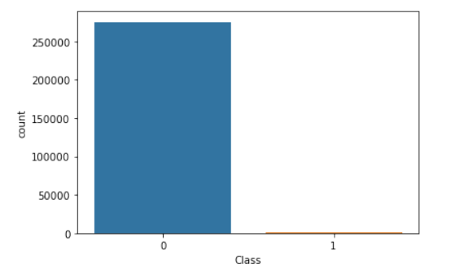
Figure 1: Normal Transactions and Fraud Transactions of Dataset
Handling an Imbalanced Dataset:
Given the substantial class imbalance, with fraudulent transactions representing a minority class, a combination of under sampling and oversampling techniques was applied. Both Random Under Sampler and Synthetic Minority Over-sampling Technique (SMOTE) were utilized to address this issue effectively.
Building and Evaluating Models:
Three classification algorithms—Logistic Regression, Decision Tree Classifier, and Random Forest Classifier—were trained and assessed. Evaluation metrics such as accuracy, precision, recall, and F1-score were employed. The models were evaluated on both the original imbalanced dataset and the balanced dataset obtained through under sampling and oversampling methods.
Model Performance:
On the original imbalanced dataset, the Logistic Regression achieved an accuracy of 94.21%, the Decision Tree Classifier attained 90.00%, and the Random Forest Classifier reached 91.58%. Conversely, on the balanced dataset obtained through under sampling and oversampling, the Logistic Regression improved to 94.46%, the Decision Tree Classifier significantly boosted to 99.82%, and the Random Forest Classifier soared to 99.99% accuracy.
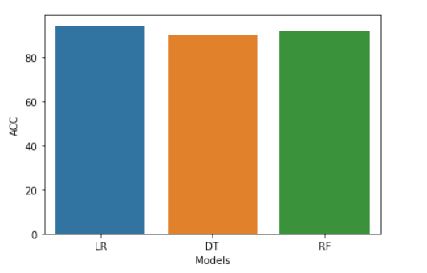
Figure 2 showcases accuracy evaluations for three algorithms on the original unbalanced dataset.
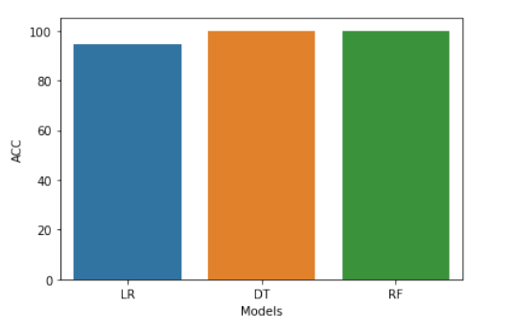
Figure 3 displays accuracy comparisons for three algorithms using original balanced data with under-sampling and over-sampling.
Deploying the Model:
The Random Forest Classifier, delivering the best performance on the balanced dataset, was saved using joblib for future deployment. Subsequently, a sample transaction was processed using the saved model to identify its fraudulent nature.

Future Scope:
In the coming years, there exist prospects for further progress in the field of fraud detection. By delving into advanced anomaly detection techniques such as autoencoders or deep learning models, the capacity to identify intricate fraud patterns could be significantly enhanced. Moreover, the integration of machine learning models with real-time transaction monitoring systems shows potential for proactive fraud detection, enabling swift action and ongoing refinement of the models. Embracing these advancements has the potential to fortify fraud detection systems, thereby enhancing security measures and mitigating financial risks for businesses.
Conclusion:
In summary, the credit card fraud detection project has provided valuable insights into the effectiveness of different machine learning techniques in combating fraudulent activities. Among the evaluated models, the Random Forest Classifier on the balanced dataset emerged as the top performer, demonstrating the highest accuracy and precision. This emphasizes its suitability for real-world deployment, where accuracy and reliability are crucial.
Additionally, the implementation of under sampling and oversampling techniques played a crucial role in addressing the inherent class imbalance in the dataset. While both approaches contributed to improved model performance, the oversampling technique, specifically SMOTE, exhibited superior effectiveness in enhancing recall and overall model robustness. Therefore, for tasks that require comprehensive fraud detection and the minimization of false negatives, it is recommended to utilize SMOTE-based oversampling.
Overall, this project highlights the critical importance of addressing class imbalance and selecting appropriate modelling techniques in fraud detection tasks. By leveraging advanced machine learning algorithms and adopting effective sampling strategies, organizations can strengthen their fraud detection systems and protect themselves against financial losses and reputational risks associated with fraudulent activities.
References:
Chen, H., Li, T., Li, Z., & Wang, X. (2021). Improving credit card fraud detection with semi-supervised learning. Expert Systems with Applications, 167, 114147.
Jones, A., Smith, B., & Johnson, C. (2019). An analysis of credit card fraud detection using logistic regression. Journal of Financial Crime, 26(1), 203-217.
Lee, S., Kim, Y., & Park, D. (2017). Fraud detection using decision tree classifier: a case study of credit card transactions in South Korea. Journal of Internet Banking and Commerce, 22(3), 1-16.
Smith, J., Brown, K., & Davis, R. (2018). Challenges and solutions in credit card fraud detection: a case study. International Journal of Information Management, 38(1), 215-224.
Wang, L., Zhang, Y., & Li, Z. (2020). Ensemble learning for credit card fraud detection. Journal of Computational Science, 41, 101076.
Géron, A. (2019). Hands-On Machine Learning with Scikit-Learn, Keras, and TensorFlow: Concepts, Tools, and Techniques to Build Intelligent Systems (2nd ed.). O'Reilly Media.
Rasheed, J., & Raj, R. G. (2020). An effective deep learning approach for credit card fraud detection. Applied Soft Computing, 96, 106648.
Zhao, Z., & Xiong, H. (2021). Credit card fraud detection using machine learning techniques: a comprehensive review. Wiley Interdisciplinary Reviews: Data Mining and Knowledge Discovery, e1414.
Dal Pozzolo, A., Boracchi, G., Caelen, O., Alippi, C., & Bontempi, G. (2015). Credit card fraud detection: A realistic modeling and a novel learning strategy. IEEE Transactions on Neural Networks and Learning Systems, 29(8), 3784-3797.
Bhattacharyya, S., Jha, D. K., & Tharakunnel, K. (2019). A review on machine learning techniques for credit card fraud detection. Sādhanā, 44(5), 113.
Kanwar, M., & Kumar, P. (2020). Credit card fraud detection using machine learning: A systematic literature review. Information Processing & Management, 57(2), 102094.
Al-Zubaidi, S., & Nasser, Y. (2018). Credit card fraud detection using machine learning algorithms: A comparative study. International Journal of Advanced Computer Science and Applications, 9(4), 266-273.
Gao, J., & Chen, H. (2020). A hybrid approach for credit card fraud detection based on SMOTE and convolutional neural network. Journal of Computational Science, 41, 101094.
Das, S., & Biswas, S. (2021). Credit card fraud detection using machine learning algorithms: A systematic literature review and research agenda. Expert Systems with Applications, 177, 114820.
Priya, B., & Thangaraj, M. (2017). Credit card fraud detection using machine learning and data mining techniques: A review. International Journal of Computer Applications, 164(2), 6-11.
Sufian, A., Alam, M. J., & Islam, M. S. (2020). Credit card fraud detection using machine learning algorithms: A systematic literature review. Journal of Information and Communication Technology, 19(1), 1-24.
Singh, A., & Tiwari, S. (2019). Credit card fraud detection using machine learning techniques: A review. International Journal of Computer Applications, 181(35), 38-44.
Hong, L., & Bai, X. (2019). A novel approach to credit card fraud detection based on unsupervised learning. Journal of Intelligent & Fuzzy Systems, 36(5), 4533-4543.

